Test Plan Document

**DNA**

**Version 1.0**



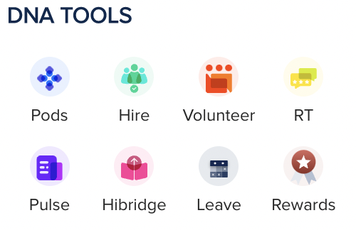

# Table of Contents

# DOCUMENT REVISION HISTORY

# 1. INTRODUCTION

# 2. TEST STRATEGY

# 2.1 TEST OBJECTIVES

# 2.2 TEST ASSUMPTIONS

# 2.3 DATA APPROACH

# 2.4 SCOPE & LEVEL OF TESTING

# 3. TEST PRINCIPLES

# 4. TEST APPROACH

# 5. TEST ACCEPTANCE CRITERIA

# 6. TEST DELIVERABLES

# 7. SCHEDULE

# 8. ENTRY AND EXIT CRITERIA

# 9. TEST ENVIRONMENTS

# Document Revision History

|  |  |  |  |  |  |
| --- | --- | --- | --- | --- | --- |
| **Date** | **Version** | **Description** | **Author** | **Reviewer** | **Approver** |
| 26 August | 1.0 | Test Plan Draft | Vinita Nainani | Gowtham Raj | Gowtham Raj |
|  |  |  |  |  |  |
|  |  |  |  |  |  |
|  |  |  |  |  |  |
|  |  |  |  |  |  |
|  |  |  |  |  |  |

# INTRODUCTION

DNA is office management software used in managing and improving the logistics within an office in order to support all the employees within that organization.

It helps us in managing various services for the employees and organization such as :-

* Employee dashboard
* Projects dashboard
* Hiring Activities
* Volunteer dashboard
* RT Tool
* Pulse Survey
* Leaves Dashboard

# TEST STRATEGY

The test strategy is created to inform project managers, developers, and testers about key issues of the testing process. The test strategy describes how the risks need to be mitigated at the test level, what criteria are needed to apply and the type of testing that needs to be performed

## 2.1 TEST OBJECTIVES

The objective of the test is to verify that the functionality of DNA works as per the specifications.

The test will execute, identify, retest all high and medium severity defects as per the entrance criteria, prioritize lower severity defects for future fixing.

            The final product of the test is twofold

* A Production ready software
* A set of test cases that can be used for functional and UAT test execution

## TEST ASSUMPTIONS

#### Key Assumptions

* In each Sprint, QA’s will getting stories for testing and last week of sprint will be more focused on testing activities and bug fixes.
* Assumed that the Back-end APIs are in working condition without any defects , else the delays caused due to re-building the APIs would impact the time and effort.
* The Duration and effort considers only – Build (with Unit testing) , Manual QA (Functional testing), and a 3 weeks of Dedicated UAT.
* QA is only limited to Manual functional testing and performance testing is out of scope
* Only Documentations considered include Test Cases, Test End report, Test Execution Report and Defect Report
* Any environmental delays or issues causing will impact the effort and schedule
* We expect corresponding environments DEV/UAT etc to be set up/provided by DNA Team
* Test data needs to be provided by DNA team
* Delay in clarifications of doubts beyond two days may lead to delay in timelines

#### General Assumptions

* Sanity Testing would be carried out once the build is ready for testing.
* Production deployment is out of scope. Schedule and duration include only till UAT completion.
* The Test team assumes all necessary inputs required during Test design and execution will be supported by Development team appropriately.
* Test case design activities will be performed by QA team.
* Test environment and preparation activities will be owned by QA team
* If it is found that new API’s need to be created, then the delay in delivering the same will lead to additional Time and Effort
* The defects will be tracked through bug tracking tool . Any defect fixes planned will be shared with Test Team prior to applying the fixes on the Test environment.

#### Functional Testing

* During Functional testing, testing team will use preloaded data which is available on the system at the time of execution.
* The Test Team will be perform Functional testing only on DNA 1.0– new functionality and existing functionality as well. (Study Insight is not considered in scope of testing)

*UAT*

* UAT test execution will be performed by end users (DNA Users) and QA/DevOps/Dev Group will provide their support during UAT phase.

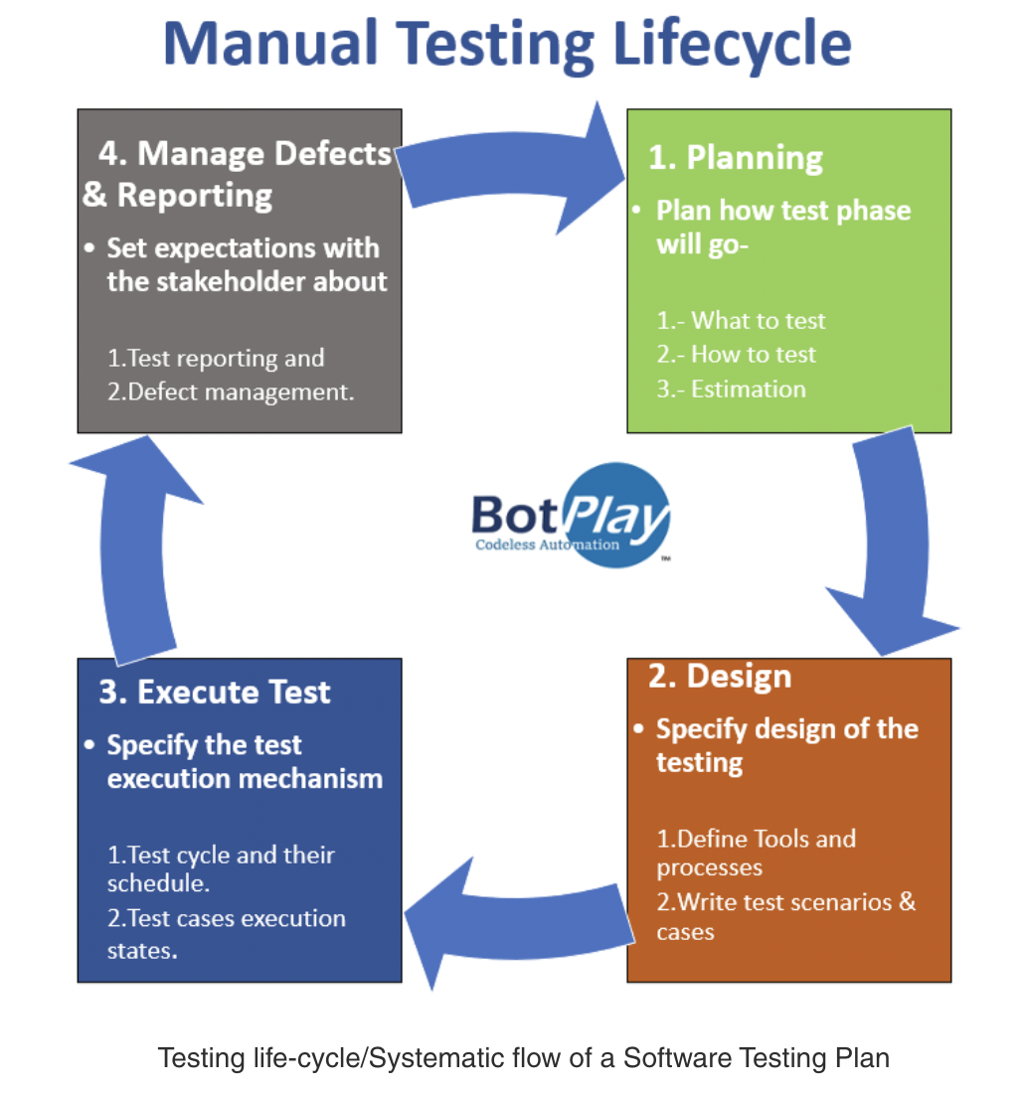

## 2.3 DATA APPROACH

In functional testing for DNA application , the testing Team will be provided access to Admin Login , allowing the QA team to test on the DNA software

## 2.4 SCOPE & LEVEL OF TESTING

TEST ACCEPTANCE CRITERIA

1. Approved Functional Specification document, Use case documents must be available prior to start of Test design phase.

2. Test cases should be approved and signed-off prior to start of Test execution

3. Development of each module should have been completed

4. Test environment with application installed, configured and ready to use state

5. Before preceding further to the next level of testing, previous level of testing should be completed and results should be shared with development team.

1. UNIT TESTING

PURPOSE: The purpose of unit testing is to check the functionality of each isolated module

TESTERS: Testing team.

METHOD: this unit testing is carried out in the application with formal Test Case documentation

TIMING: at the beginning of each following cycle

1. INTEGRATION TESTING

PURPOSE: The aim of integration testing is to test the interfaces between the modules and expose any defects that may arise when these components are integrated and need to interact with each other.

TESTERS: Testing Team.

METHOD: This integration testing is carried out in the application with formal Test Case documentation

TIMING: after unit test is completed and next module is ready

1. SANITY TESTING

PURPOSE: The purpose is to ascertain that the bugs have been fixed and no further issues are introduced due to these changes

TESTERS: Testing Team.

METHOD: This test will be executed as per the bugs reported in defect report.

TIMING: after unit test and integration test is completed . Also ,  if new modules are added to the application

1. USER ACCEPTANCE TEST (UAT)

PURPOSE: this test focuses on validating the business logic. It allows the end users to

complete one final review of the system prior to deployment.

TESTERS: the UAT is performed by the end users (L1, L2 and L3).

METHOD: Since the business users are the most indicated to provide input around business

needs and how the system adapts to them, it may happen that the users do some validation

not contained in the scripts. Test team write the UAT test cases based on the inputs from End

user (L1,L2 and L3 users) and Business Analyst’s.

TIMING: After all other levels of testing (Exploratory and Functional) are done. Only after this

test is completed the product can be released to production.

1. **TEST PRINCIPLES**

* Dev team will provide the access to staging environment
* Any changes except for defects would lead to impact to timelines / Effort
* Testing will be focused on meeting the business objectives, cost efficiency, and quality.
* There will be common, consistent procedures for all teams supporting testing activities.
* Testing processes will be well defined, yet flexible, with the ability to change as needed.
* Testing activities will build upon previous stages to avoid redundancy or duplication of effort.
* Testing environment and data will emulate a production environment as much as possible.
* Testing will be a repeatable, quantifiable, and measurable activity.
* Testing will be divided into distinct phases, each with clearly defined objectives and goals.
* There will be entrance and exit criteria

# TEST APPROACH

Before detailed testing, a basic sanity tests would be required to be carried out to confirm if all the necessary components of the application are Up-and running with data fetch possible from the front end.

**Unit Testing** will be performed to check if individual units of the applications are working as intended. The unit testing is carried out by feeding the input/performing actions and validates the output from the application.

The purpose of this test is to make sure critical defects are removed before the next levels of testing can start.

**Integration Testing** will be performed after the unit testing of each consecutive module has been completed and 2 different modules are integrated. The purpose of this test is to make sure that if 2 different modules are integrated, the functionality of any module should not be hampered, and it should work as intended.

**Sanity Testing** will be performed after the application is completely developed and all the bugs raised in previous phases have been fixed.

**User Acceptance Testing** will be performedafter all levels of testing are completed and last 3 weeks of schedule will be dedicated to UAT Testing , before moving on to production.

# TEST ACCEPTANCE CRITERIA

1. Approved Functional Specification document, Use case documents must be available prior to start of Test design phase.
2. Test cases approved and signed-off prior to start of Test execution
3. Development completed, unit tested with pass status and results shared to Testing team to avoid duplicate defects
4. Test environment with application installed, configured and ready to use state

# TEST DELIVERABLES

|  |  |  |  |
| --- | --- | --- | --- |
|  | **Deliverable Name** | **Author** | **Reviewer** |
| 1. | Test Plan | Test Team | Test Lead |
| 2. | Test Case Document | Test Team | Test Lead |
| 3. | Logging Defects | Test Team | Test Lead |
| 4. | Defect Tracking Report | Test Lead | Test Lead/ Project Manager |
| 5. | Daily/ Weekly Status Report | Test Team | Test Lead/ Project Manager |

# SCHEDULE

The chart added below is to explain the timing of the dev activity and it also cover when each phase of development activity will start and end. In each sprint, QA will be working on testing activities.

* It is expected that the testers will start executing testcases from the second week of every sprint for the cycles described above.
* The defects will be tracked through Jira only.
* Testing team will be doing UI testing for Sprint I, where they will be comparing the mockup and actual and convey the difference observed to dev team for fix/improvement.

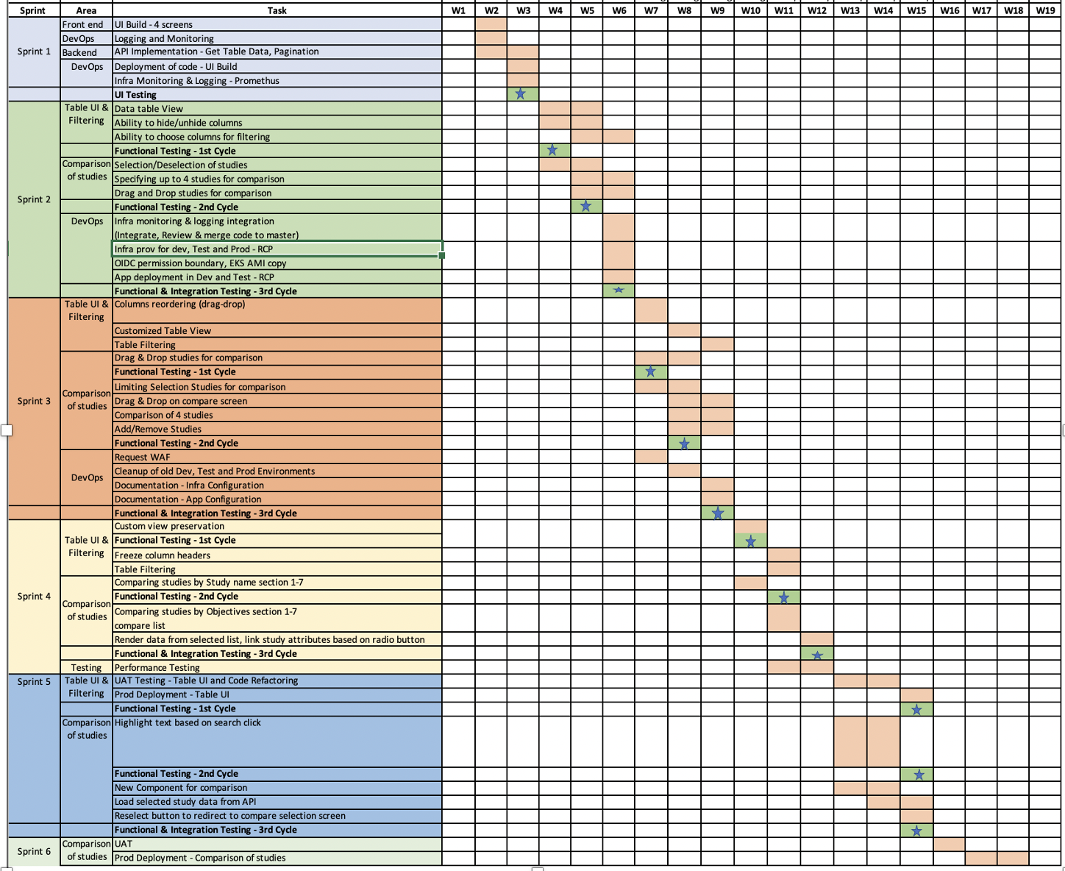

*“Please note that these dates are tentative.”*

# ENTRY AND EXIT CRITERIA

## Functional Test Entry Criteria

* The migration of the code and fixes need to be assessed at the end of each cycle.
* Prototype testing is completed and approved by client.
* Functional stories are well defined in Jira and all queries should be answered.
* Test Cases have been prepared.
* Test data has been created.
* The environment for testing is ready, all the tools that are required are available and ready.
* Complete or partial Application is developed, and unit tested and is ready for testing.

## Functional Test Exit Criteria

* Execution of all the functional test cases has been completed.
* No critical or P1, P2 bugs are open.
* Reported bugs have been acknowledged.
* Submission of the final test report to Roche stakeholder’s review.
* Test scripts, logs, and observations to be archived/stored in Roches SharePoint.

# TEST ENVIRONMENTS

|  |  |  |  |
| --- | --- | --- | --- |
| **Environment Name** | **Test Type** | **Description** | **Configuration/Access** |
| STAGE_01 | Functional Testing | This env will be used only to test functionality of the application. | * CPU – TBD * Memory – TBD |